EDA (Exploratory
Data Analysis)

WEEK - 6

REPORT

SUBMITTED BY:

- SAHANAA SREE
E25DA045

WEEK - 6

Problem Statement:

To develop a Healthcare Analytics Dashboard using Power BI by transforming and organizing patient, admission, billing, medical condition, and insurance data to generate meaningful healthcare insights.

Objective:

. To clean and transform the healthcare dataset.

. To create Fact and Dimension tables.

. To establish relationships between the tables.

. To analyze patient count, billing amount, medical conditions, admission types, and insurance providers.

. To create an interactive Power BI dashboard for easy visualization and analysis.

Tasks and Deliverables:

Created Fact Billing, Dim_Patient, and Dim_Admission tables.

Merged and cleaned the required data.

Created relationships between the tables.

Added key measures for patients and billing.

Designed the final Healthcare Dashboard with visuals and filters.

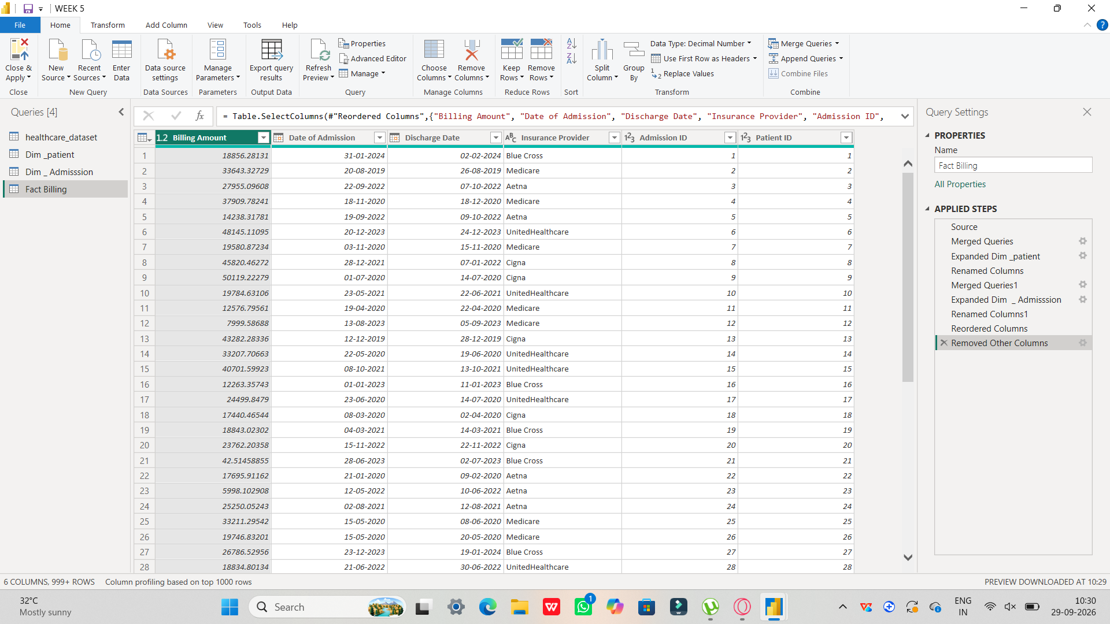

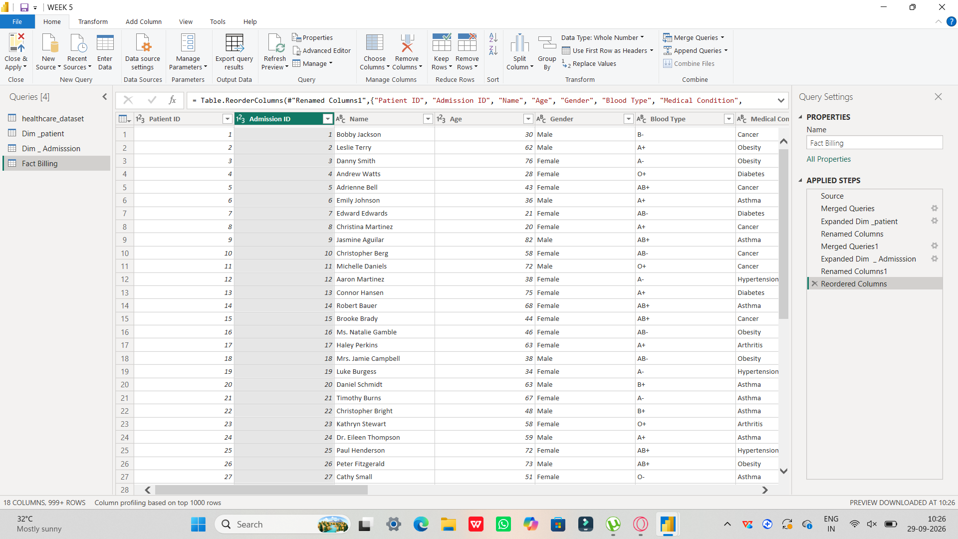

MEASURES AND CONNECTIONS:

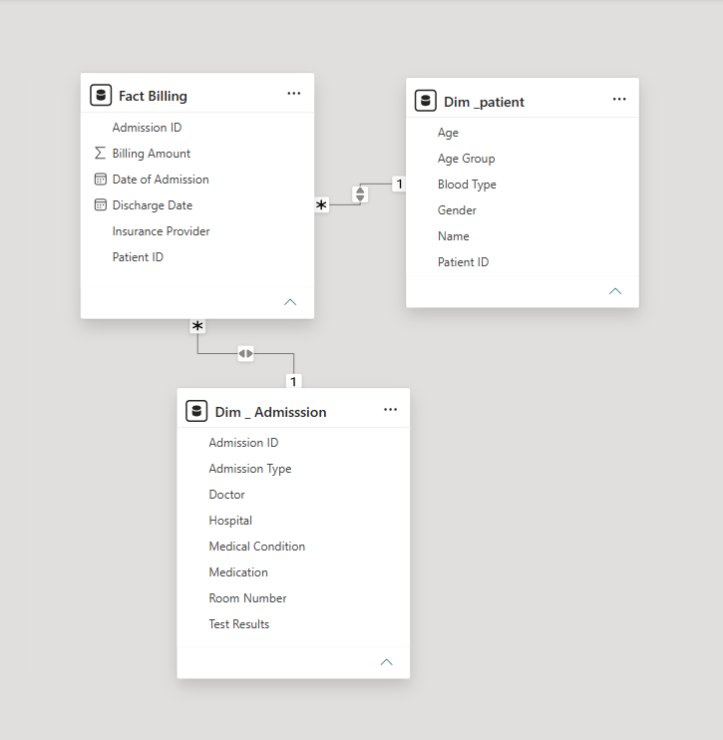

DASHBOARD :

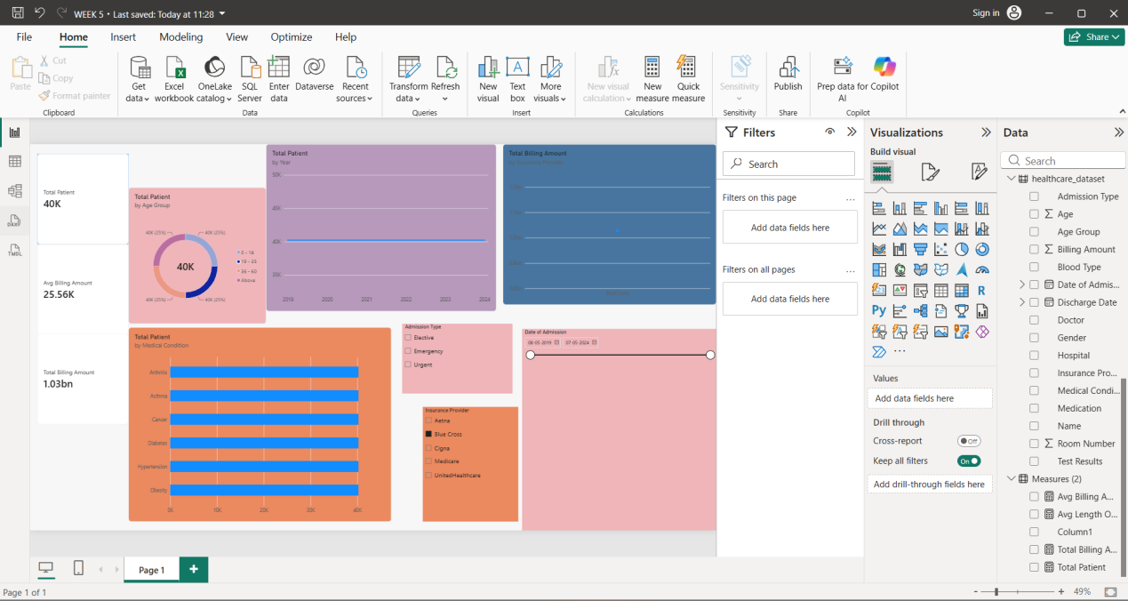

Conclusion:

The healthcare dataset was successfully cleaned, transformed, and organized using Power BI.
A structured data model and interactive dashboard were created to provide clear insights into patients, billing, medical conditions, admission types, and insurance providers, helping users understand healthcare data more effectively.

